PROG6212

PART 2

Aaliyah Allie – ST10212542

2024

Contents

Introduction 2

Design Changes 3

Main Window 3

Create Account Window 4

Lecturer Login Window 5

Programme Coordinator Login Window 5

Lecturer Dashboard Window 6

Submit Claim Window 7

Supporting Docs Window 7

View Claims Window 8

Programme Coordinator Dashboard Window 9

Updated Database Structure 10

SQL 10

Database Layout 11

Account User Table 11

Claims Table 12

Supporting Documents Table 12

Workflow 13

For lecturers: 13

For Coordinators: 13

GITHUB COMMIT HISTORY 14

GITHUB REPO LINK 16

Conclusion 17

# Introduction

In this part of the POE, we were supposed to enhance the designs done in Part 1 through the creation of functionality and establishment of project flow. We were also to reflect on the feedback given by our lecturer in Part 1 and discuss how such improvement has been made in Part 2.

While I received minimal feedback, since I got full marks, I took this as an opportunity to make some improvements in the design, workflow, and functionality of Part 2. I also updated my previously designed database schema.

Part 2, I continue working with Windows Presentation Forms (.NET); however, I plan to migrate into the MVC framework in Part 3 per the stipulation in the project requirements. Application flow has remained the same as the framework I earlier outlined in Part 1. Since we needed to add functionality I have also added a few unit tests into my project.

This report will explain all changes I have made on the application and further include screenshots showing any kind of design modifications made.

# Design Changes

Based on design changes not much changed I did just add in a colour scheme by making all the windows blue, font black and buttons white. For some windows changes were made to make displaying information captured easier by having more labelling and having more structure.

## Main Window

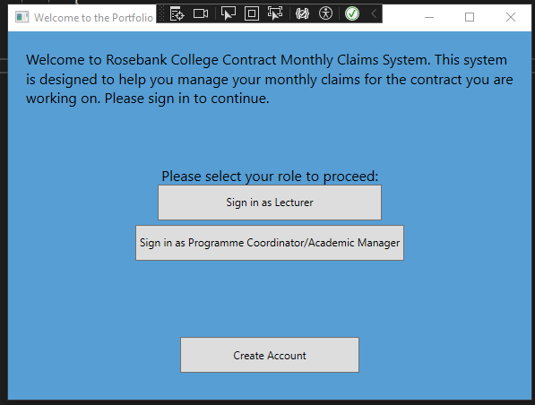

## Create Account Window

## Lecturer Login Window

## Programme Coordinator Login Window

## Lecturer Dashboard Window

## Submit Claim Window

## Supporting Docs Window

## View Claims Window

## Programme Coordinator Dashboard Window

# Updated Database Structure

## SQL

CREATE DATABASE POE;

USE DATABASE POE;

-- Create the Lecturer table

CREATE TABLE AccountUser(

    AccountUserID INT IDENTITY(1,1),

    FirstName VARCHAR(50) NOT NULL,

    LastName VARCHAR(50) NOT NULL,

    Email VARCHAR(100) NOT NULL,

    PhoneNumber INT NOT NULl,

    PasswordHash VARCHAR(255) NOT NULL,

    AccountType NVARCHAR(50) NOT NULL,

PRIMARY KEY (AccountUserID),

);

-- Create the Claims table

CREATE TABLE Claims (

    ClaimsID INT PRIMARY KEY IDENTITY(1,1),

    ClassTaught VARCHAR(100),

    NoOfSessions INT NOT NULL,

    HourlyRatePerSession DECIMAL(10, 2) NOT NULL,

    SupportingDocumentPath NVARCHAR(255),

    ClaimStatus NVARCHAR(50) CHECK (ClaimStatus IN ('Pending', 'Approved', 'Rejected')),

    ClaimTotalAmount AS (NoOfSessions * HourlyRatePerSession) -- Computed column

);

-- Create the Supporting Documents table

CREATE TABLE SupportingDocuments (

    DocID INT PRIMARY KEY IDENTITY(1,1)

    DocName VARCHAR(100) NOT NULL,

    FilePath VARCHAR(255) NOT NULL,

    SubmissionDate DATETIME NOT NULL

);

-- Create the Claims Status table

CREATE TABLE ClaimsStatus (

    ClaimStatusID INT PRIMARY KEY ,

    ClaimStatusConfirmation NVARCHAR(50) CHECK (ClaimStatusConfirmation IN ('Pending', 'Approved', 'Rejected'))

);

## Database Layout

### Account User Table

### Claims Table

### Supporting Documents Table

# Workflow

The flow works as follows for the program.

## For lecturers:

1.Create Account

2. Sign In

3. Go to Dashboard

4. Submit Claims

5. Add supporting docs

6.View Claims (edit or delete claims)

## For Coordinators:

1.Create Account

2.Sign In

3. Go to Dashboard

4.View Claims Submitted

5.Review (Approve/Reject/Pending

# GITHUB COMMIT HISTORY

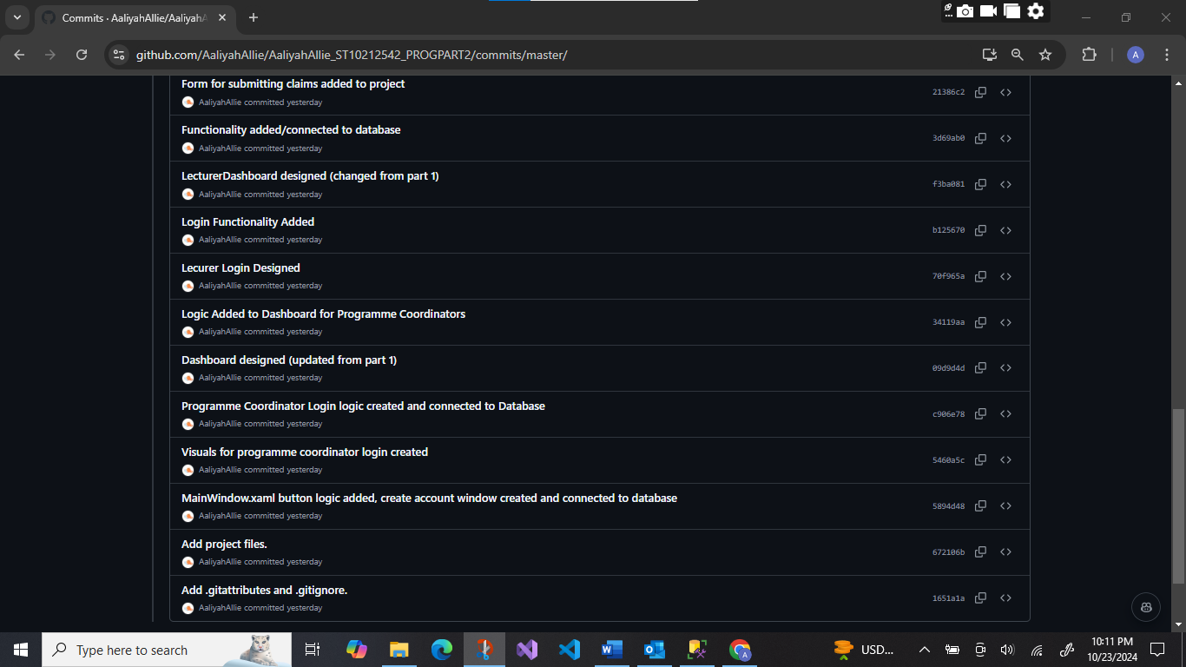

# GITHUB REPO LINK

Please follow the link below to find my GitHub repo:

<https://github.com/AaliyahAllie/AaliyahAllie_ST10212542_PROGPART2.git>

# Conclusion

In conclusion, Part 2 of the POE allowed for quite an improvement from an initial design. The application was more functional and friendlier for its users. Even though I received less feedback from other students, I took this opportunity to fine-tune the workflow and all visual elements of the application so it would be harmonious and interesting for the user. The changes in the database schema and addition of unit tests further enhanced application stability and efficiency. The changes that have been implemented will prove a good platform on which to proceed with developments when transitioning to the MVC framework in Part 3. The report describes the changes made, emphasizing commitment to continuous improvement and adaptation in the project.